## Delineators

Traditionally, one of the most difficult things to do when creating a traffic plan was run out lines of bollards, cones, barrels, etc. The RapidPlan delineator tool allows you to drag out lines of devices in seconds.

**Types of delineators available:**

There are thirteen standard types of delineators available:

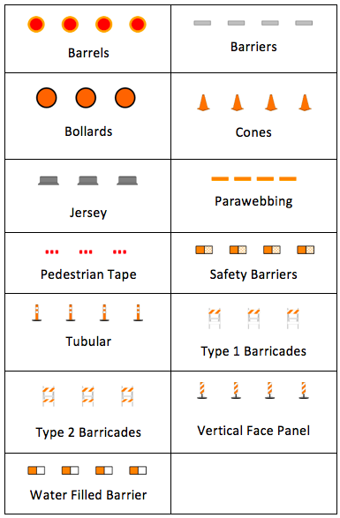

Types_of_Delineators